Cry me a river

Going beyond the crisis response: building trust and maintaining legitimacy in environmental flows

A National Workshop
Melbourne Law School
27-28 November 2017

Report to Academy of social Sciences Australia

Erin O’Donnell*ª, Avril Horne^{b}, Lee Goddenª and Brian Head^{c}

*Corresponding author email: erin.odonnell@unimelb.edu.au
a – Centre for Resources, Energy and Environment Law, Melbourne Law School, University of Melbourne
b – School of Engineering, University of Melbourne
c – School of Political Science, University of Queensland
Contents
Introduction 3
Part 1: Cry me a river 5
Where are the people? 5
Lasting support is essential for environmental flows programs 6
What is a ‘legitimate’ environmental flows program? 6
Building trust and legitimacy 7
Who is ‘the community’? 8
Building trust and engagement 9
Power relationships 9
Learning lessons 9
A future agenda 9
Acknowledgements 10
Part 2: Workshop Overview 11
Background 12
Workshop aims 14
Workshop outcomes 14
Workshop program 15
Detailed Program: Day 1 16
Detailed Program: Day 2 17
Invited participants 18
Participant feedback 19
Legitimacy as a measure of success for environmental flows programs 19
Most important issue for the future agenda 19
Feedback on the workshop 20
Appendix A: Discussion papers 21
Appendix B: Material for group discussions 22
Day 1 Afternoon whole group discussion 22
What do we mean by legitimacy? 22
The core challenge 22
Day 2 Small group discussions 23
Who is the ‘community’? 23
How can we measure ‘legitimacy’? 23
Who Should play a leadership role in building ‘legitimacy’? 24
Day 2 Final whole group discussion: What is the future agenda? 24
Appendix C: Participant feedback 25

Report overview
This report provides a summary of the workshop held on 27-28 November, at Melbourne Law School, which explored how to build lasting support and maintain the legitimacy of environmental flows programs in Australia. This workshop was funded by the Academy of Social Sciences in Australia, and was hosted by the Centre for Resources, Energy and Environment Law at the University of Melbourne, in partnership with the Institute for Social Science Research at the University of Queensland, and the Environmental Hydrology and Water Resources Group in the Department of Infrastructure Engineering, at the University of Melbourne. The conveners of the workshop were Dr Erin O’Donnell, Dr Avril Horne, Prof Brian Head and Prof Lee Godden. The report authors would like to acknowledge the contribution of all participants in the workshop. This report could not have been prepared without their generous, insightful, and frank discussion of the issues.
This report is presented in two parts. Part 1 is an easily accessible summary of the issues and outcomes of the workshop, designed for a general audience. Part 2 provides a more scholarly overview of the background issues, as well as the details of the two-day workshop.

Part 1: Cry me a river

Where are the people?
Water for the environment in Australia has overwhelmingly focused on the ecological needs for water. Over the past thirty years, major law and policy reform that recovered water for the environment was driven by repeated ecological crises. Blue-green algae blooms and salinity in the 1990s resulted in the Murray-Darling Basin Cap. In the early 2000s, widespread drought and decline in river health gave rise to the Living Murray agreement, which was rapidly followed by the unprecedented extreme water scarcity of the Millennium drought from 2007-2010, and the eventual Murray-Darling Basin Plan. At each critical moment, there was broad political support for the emergency response, culminating in the 2010 commitment from the Commonwealth government to spend $13.8 billion to increase environmental flows and improve water security throughout the Murray-Darling Basin.
But does this crisis response reflect an enduring acceptance of the environment as a legitimate user of water, or even understanding of the need for environmental flows? Recent market research conducted by the VEWH suggests that it does not, with the complex language of water policy acting as a barrier to both understanding and support, even in communities with a close relationship to water sources and water-dependent industries. Without this basic level of awareness, it is difficult to engage communities and build legitimacy for environmental flows.
Building ongoing support requires understanding, but also the ability to personally identify with the issue. One of the big challenges in Australia has been making the connection between people and the environment. When given a copy of the latest Reflections booklet published by the Victorian Environmental Water Holder (VEWH) in 2013, the response of environmental water managers in the western USA was telling: how could Australian environmental water managers get away with placing a bird on the front cover? Where were all the people? Over the past decade of reporting on how and where environmental water has been used in Victoria, people have only featured once on the front cover, and that was in 2017. At the national level, of the ten ‘snapshot’ reports released by the Commonwealth Environmental Water Holder (CEWH) in 2017, only one featured a person on the front cover. Although there is a core sector of the community who values the environment for its own sake, broadening the basis of support requires more people to understand and accept the problem, and the solution offered by environmental flows.
In November 2017, twenty environmental flows specialists from government, academia, and non-government organizations gathered in Melbourne for two days, to share insights and develop a new approach for building and maintaining lasting support for environmental flows programs across Australia. The following discussion draws on the presentations, small groups, and facilitated discussions at the workshop (see Acknowledgements below).

Lasting support is essential for environmental flows programs
Good water governance is globally recognized as being critically dependent on efficacy, efficiency, and trust and engagement (legitimacy). Water governance is often shaped by a top-down legal framework, but successful policies also require a high level of participation from a diverse range of stakeholders over the long term. This is especially true for environmental flows programs, which explicitly connect social and ecological values for healthy rivers and communities.
In 2007, environmental flows were defined as: “the quantity, timing, and quality of water flows required to sustain freshwater and estuarine ecosystems and the human livelihoods and well-being that depend on these ecosystems”. Ten years on, environmental flow assessment methods are now more focused on stakeholder participation and co-design, and recognize the dual role of environmental flows in supporting ecological and societal values, especially for those who rely on instream values to support their livelihood. However, environmental flows programs continue to be framed as technological ‘fixes’ for a specific problem, rather than recognizing that successful environmental management requires ongoing operation over a long period, which requires a continued investment in building, and maintaining, legitimacy.
Australia is widely recognized as a world leader in water governance, particularly in environmental flows and water markets, but Australia has been less successful in maintaining the legitimacy of environmental flows programs over the long term (as demonstrated by the backlash to the Murray-Darling Basin Plan, ongoing political disagreements, and the recent experiences of ‘theft’ of environmental water in New South Wales). As momentum builds for increasing Indigenous access to and ownership of water rights around Australia, it is increasingly urgent to develop a strategy for water law and governance that recognizes the legitimacy of the perspectives and interests of Indigenous Australians. With the support of Indigenous People, traditional ecological knowledge can also contribute to building connections between ecological and socio-cultural values in water through concepts such as cultural flows.

What is a ‘legitimate’ environmental flows program?
‘Legitimacy’ is a complex concept. In law, legitimacy stems from authority: the power of a particular person or organization to make particular decisions. However, while this will demonstrate legitimacy at a particular point in time, it will not necessarily maintain legitimacy through time, which requires continued investment in building support for these (or other) sources of authority.
Political legitimacy can be achieved by focusing on the effectiveness of service delivery (instrumental legitimacy), or by emphasizing shared values (substantive legitimacy). In the environmental flows context, this means there is a need to build a shared understanding and acceptance of the problem, and a shared vision of success. To do so, it can help to acknowledge the multiple dimensions of success, including legitimacy, scientific validity, and implementation capacity (Figure 1).
Crucially, this doesn’t mean that there needs to be consensus on the issue of environmental flows, but rather, that even if someone doesn’t like a decision, they can still accept it as a valid decision. Building support for the ‘rules of the game’ is a stronger basis for enduring legitimacy than relying on populist policies.
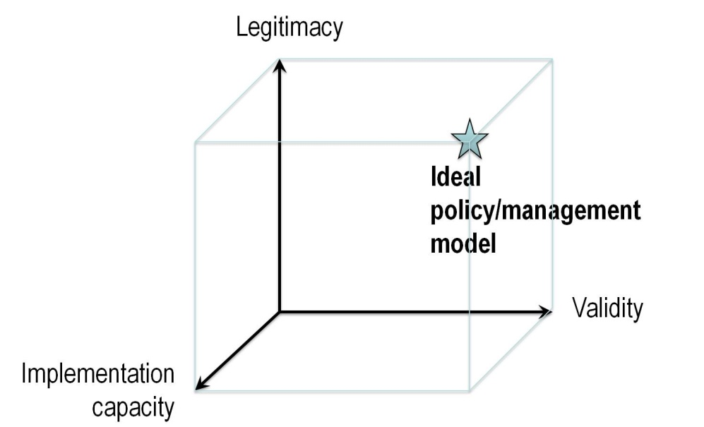
Figure 1 Multiple dimensions of successful environmental flows policies (Daniell, 2017)

Building trust and legitimacy
Legitimacy needs to be a core component of environmental flows programs. The building blocks of legitimacy are:
- The process: including explicit consideration of access, equal representation, transparency, accountability, consultation and cooperation, independence and credibility;
- The outcomes: whether the intervention actually solved the problem, or otherwise achieved its goal; and
- Why the outcomes matter, and to whom.
We propose an approach centred on these core elements: (1) building relationships; (2) demonstrating outcomes and why they matter; and (3) building understanding and engagement with science and research, and other diverse systems of knowledge (Figure 2).

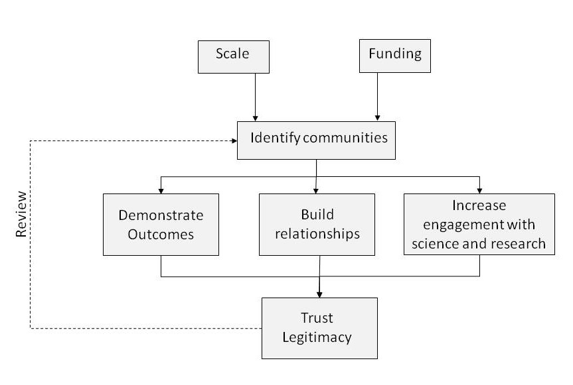
Figure 2 Building trust and legitimacy for environmental flows programs

Who is ‘the community’?
To overcome historical and systemic barriers to effective engagement, it is worth considering who has been excluded from the process of environmental flows allocation and management (and water management more broadly). In Australia, this means acknowledging the ongoing role of settler laws and legal frameworks in disenfranchising Indigenous Australians, which is exacerbated by their historical exclusion from water rights. Moving beyond the standard view of the community to engage more widely with other sectors is an important step in broadening community awareness and support.
The next step is to consider who is affected by environmental flows allocation and management? The following questions can help identify the broader community:
- Who (potentially) benefits? Who is (potentially) harmed? (e.g. irrigators, rural towns, recreational fishers, tourists, people who value healthy rivers even if they don’t visit them)
- Who can contribute to environmental flows?
- Who is operationally involved in environmental flows? (e.g. water authorities, land owners, storage managers, irrigators, compliance officers)
- Who delivers the mandate for environmental flows? (e.g. key influencers, sector leaders, peak bodies, local champions)
- Who maintains the legal and regulatory frameworks?
- Who can demonstrate the outcomes? (e.g. researchers, citizen science)
Any strategy for building trust also needs to include re-assessment of and re-engagement with communities over time.

Building trust and engagement
Strategies to engage and build trust with a particular community should:
- Demonstrate outcomes, including environmental, economic, social, and cultural;
- Build confidence in the credibility of the evidence base, for example, by using community derived data, or citizen science processes;
- Have transparent and accountable processes that minimise harm to others;
- Develop relationships, especially local relationships that show personal credibility;
- Establish ambassadors and find champions in the relevant community;
- Manage the squeaky wheels (for example, by addressing perceived as well as actual harm);
- Build baseline literacy with simple repeated messages.

Power relationships
Building trust and legitimacy requires investing in building capacity across the community to contribute to, and even challenge, the operation of environmental flows programs. Engagement strategies also need to consider the different responses required to manage ‘squeaky wheels’ (individuals or organizations with the ability to make their opinions known), the often silent ‘middle ground’ (individuals and organizations with limited exposure to environmental flows, and who can become a powerful source of support or skepticism), and historically disenfranchised minorities (where lack of access can compound their exclusion).

Learning lessons
Building on the success of others is a powerful tool for developing best practice. One of the success stories in river health is the Glenelg-Hopkins Catchment Management Authority ‘Percy the Perch’ engagement program, which successfully used innovative and eye-catching video, and leveraged local values (and a love of Warnambool) to drive donations to fish habitat.
In the Murray-Darling Basin, the Murray-Darling Wetlands Working Group (MDWWG) has established long-term relationships over 25 years. By building credibility over time, the MDWWG has invested in innovative environmental water management, while largely avoiding the community backlash that so often accompanies the use of the water market to enhance environmental flows.

A future agenda
The increasing unwillingness of the public to rely on subject matter experts as sources of authority shows the crucial importance of building a broader, lasting base for community support of environmental flows. Technical expertise can help to answer specific questions, but on its own, is no longer a reliable currency with which to purchase broader acceptance of the answers. There is no policy reform that cannot be reversed, and recent increases in environmental flows over the past decade across Australia remain vulnerable.
Achieving lasting legitimacy for environmental flows programs will need significant investment in new skill sets, beyond the traditional science, technology and engineering approach to water resource management. We need to invest in social scientists, and communications and engagement experts. This investment needs to occur at intersecting vertical (e.g. local, state, or federal) and horizontal (e.g. different river basins, or irrigation districts) spatial scales.
Perhaps most importantly, while building trust and maintaining legitimacy needs to be part of the core activities of environmental flows programs, it cannot be simply another line item on an annual report. Measuring and reporting on trust and engagement should form part of adaptive management processes, but with the focus on driving improvement rather than reporting on outcomes. Legitimacy is a state that needs to be maintained, rather than an output that can be delivered.

Acknowledgements
The authors gratefully acknowledge the support of the Academy of Social Science in Australia who provided the funding for the November workshop. We are also grateful to the Centre for Resources, Energy and Environment Law at Melbourne Law School for sponsoring the event, and providing a venue and administrative support.
The authors also wish to acknowledge the contributions of all participants at the workshop, who generously and frankly shared their experience and insights into the challenge of broadening the base of support for environmental flows programs in Australia. The findings presented in this report stem directly from the presentations and group discussions held during the workshop. To respect the Chatham House rule, we have not included direct reference to individuals, but this report could not have been produced without the contributions of the workshop participants.
We do wish to acknowledge some specific contributions:
- Katherine Daniell, whose excellent presentation was the source of Figure 1 (above);
- all the authors of discussion papers, whose examples have been used to highlight particular lessons.

Part 2: Workshop Overview
Water law and policy reform in Australia typically occurs in response to environmental and social crises, such as the Millennium Drought in the Murray-Darling Basin. Increasing environmental flows (the quantity, timing, and quality of water flows required to sustain freshwater ecosystems) was a pivotal part of that crisis response. Water reform in response to an emergency often enjoys broad political support, however, the ongoing need for trust, engagement and participation, to ensure the longer term acceptance of the measures adopted during the crisis, is often overlooked. It is time to reexamine the role of ‘legitimacy’ in environmental flows implementation.
Legitimacy can be functionally expressed as the combination of input legitimacy, and output legitimacy. Input legitimacy focuses on the process, and whether it was acceptable to the affected people. Input legitimacy requires explicit consideration of access, equal representation, transparency, accountability, consultation and cooperation, independence and credibility.
Output legitimacy focuses on the solution, and whether the intervention actually solved the problem, or otherwise achieved its goal. In addition to demonstrating effectiveness (discussed above), output legitimacy emphasizes awareness, acceptance, mutual respect, active support, robustness and common approaches to shared problem solving. It is not enough to simply recover the required volume of environmental water, or alter the operation of the dam to provide the required water regime: the environmental water organizations need to build a bridge between the different community groups affected by water resource use. Globally, good water governance is recognized as being critically dependent on efficacy, efficiency, and trust and engagement (legitimacy). Water governance is often shaped by a top-down legal framework, but successful programs also require a high level of participation from a diverse range of stakeholders, over the long-term. This is especially true for environmental flows programs, which explicitly connect social and ecological values for healthy rivers and the communities who depend on them for their livelihoods (see discussion below).
Australia is widely recognised as a world leader in water governance, particularly in environmental flows and water markets. Australia has been less successful in maintaining the legitimacy of environmental flows programs over the long term (as demonstrated by the backlash to the Murray-Darling Basin Plan, and the recent experiences of ‘theft’ of environmental water in New South Wales, which have underscored the irrigation community’s lack of acceptance of the environment as a legitimate user of water). Australia is also looking to expand water resource development to northern Australia, where building trust and engagement between government agencies and Indigenous Australians will be much more significant for the success of the environmental flows programs.

Background
In 2007, the Brisbane Declaration established international consensus on the definition of environmental flows as: “the quantity, timing, and quality of water flows required to sustain freshwater and estuarine ecosystems and the human livelihoods and well-being that depend on these ecosystems”.
The Brisbane Declaration committed to broadening stakeholder engagement, and building the networks and capacity required to implement, maintain and enforce environmental flows. Over a decade later, environmental flow assessment methods are now cognizant of stakeholder participation and co-design, and recognize the dual role of environmental flows in supporting ecological and societal values, especially for those who rely on instream values to support their livelihood. However, environmental flows programs continue to be undertaken as technological ‘fixes’ for a specific problem, rather than recognizing that successful environmental management requires ongoing operation over a long period. Long-term operation requires a continued investment in building, and maintaining, legitimacy, in the eyes of the wider community, as well as directly affected stakeholders. Crucially, this doesn’t mean that there needs to be consensus on the issue of environmental flows, but rather, that if someone doesn’t like a decision, they can still accept it.
Measuring success for environmental flows programs has historically focused on two metrics: effectiveness (did the environmental flows provided perform the ecological function that was required?) and efficiency (did it do so at a cost that was acceptable, and minimised where practicable?). In debates about the need for environmental flows, these metrics were essential to the decision to provide water to the environment, especially when doing so meant that it was not provided to other consumptive uses. However, we are now starting to understand that legitimacy is just as crucial to the long-term success of environmental flows programs. Trust and engagement need to be built at the beginning, and maintained throughout the life of the program.
Environmental flows organizations, both government and NGO, are getting better at making these environmental flows management decisions transparent (an important element of input legitimacy), but real legitimacy requires expanding the sphere of influence, so that local communities are invested in making the best decisions for environmental flows in their local context. By focusing on both input (the process) and output (the outcome) legitimacy, environmental flows policy makers and practitioners can embed legitimacy throughout the environmental flows management process.
Building a real partnership between all the stakeholders in an environmental flows program, so that they are all invested in achieving a successful environmental water outcome, takes time, effort and humility. One often missing element is a specific investment in building partnerships with indigenous peoples, particularly in the context of historical colonization and disenfranchisement. Legitimacy of an environmental water program will depend on giving all voices equal access, and accepting that there are many different forms of knowledge. However, success of environmental flows programs does not, and should not, require achieving consensus on the outcome. In the Murray-Darling Basin, debates on the relative importance of minimizing social and economic impacts of water recovery for the environment showed that if it is necessary to demonstrate no impact, the environment will be unlikely to receive all the water it needs. Further, recent reaction to analysis undertaken by Ernst and Young on behalf of the Commonwealth Government on how to avoid such impacts has been dismissed by state governments and sections of the irrigation community, demonstrating how difficult it can be to regain trust once it has been lost.

Workshop aims
To begin to address these challenges, a multi-disciplinary two-day workshop was held at Melbourne Law School, on 27-28 November 2017. The workshop brought together researchers, policy makers, and practitioners, and drew on their unique experiences to propose new ways to build and maintain legitimacy as a key investment, and fundamental indicator of success, for environmental flows programs.
The workshop aims were to take the next step in making legitimacy a core metric for success of environmental flows programs, by:
- Drawing on the latest social science research (see Appendix A) to identify new tools that can be applied to the problem of building trust and engagement in water governance and environmental flows, including how to report on levels of trust and engagement throughout a program;
- Building consensus in a multi-disciplinary field on the need to establish legitimacy as a core requirement for upfront investment;
- Identifying potential barriers to legitimacy, and lessons from the field; and
- Identifying new institutional arrangements that enhance legitimacy by supporting deep engagement and participation throughout the environmental flows program.

Workshop outcomes
This workshop has established a network of researchers (in social science, law, economics and engineering) and practitioners in environmental flows. This network has an ongoing interest in building the concept of legitimacy into environmental water management programs, and as a tool of public policy in water management more widely.
The workshop outcomes will be disseminated in three ways:
- A referred journal article that synthesizes the workshop discussion on how to enhance and measure legitimacy for environmental flows programs. This article will be part of a Special Issue of the Australasian Journal of Water Resources in 2018, dedicated to the topic of legitimacy and environmental flows.
- An article in The Conversation (or similar open access website), to share the outcomes with a wider public readership. This article will be based Part 1 of this report.
- A written report (this report) to be hosted on the websites of ASSA and the Centre for Resources, Energy and Environment Law, at the University of Melbourne Law School.

Workshop program
The workshop included a number of formal presentations, small group discussions and whole workshop discussions (see detailed program below).
Day 1 focused on a multi-disciplinary approach to legitimacy, and was designed to facilitate knowledge exchange and dialogue between academic researchers and practitioners in environmental flows. There were nine short presentations based on discussion papers produced by each presenter (1500-2000 words), which were shared with all participants prior to the workshop. Each session included a moderated discussion between the participants, using Chatham House rule to ensure confidentiality. Themes and outcomes from this discussion are outlined in Report 1. Day 1 was followed by a dinner at a local Carlton restaurant (attended by 12 workshop participants).
Day 2 of the workshop built on the knowledge exchange of Day 1 and moved into the identification and development of new tools and methods to enhance legitimacy, how to measure and report on legitimacy as a metric for the success of environmental flows programs, and potential barriers to enhancing legitimacy. This included a session in which the participants were divided into three small groups, who tackled specific issues relating to legitimacy (see Appendix B), followed by a short presentation from each group to the rest of the workshop participants.

Detailed Program: Day 1
8:30-9am | Workshop registration and arrival (Level 9, room 920, Melbourne Law School)
9am-9:45 | Welcome  Welcome to country (Wurundjeri Elder)  Welcome to CREEL – Lee Godden  Workshop approach and objectives, including the importance of building and maintaining a dialogue between social science, law, policy, ecology and hydrology – Brian Head
9:45-10:15 | Social licence 2.0: building and maintaining community support  David Papps, Commonwealth Environmental Water Holder
10:15-11 | Session 1: Why is legitimacy important for environmental flows? (facilitated by Avril Horne)  - Katherine Daniell (ANU) – How to think about legitimacy and social engagement: recent research findings  - Erin O’Donnell – Legitimacy as a metric for measuring success of environmental flows
11:11:30 | Morning tea
11:30-1pm | Session 2: Setting the scene: examples of success and room for improvement (facilitated by Erin O’Donnell)  - Tony McLeod (Murray-Darling Basin Authority) – Lessons from the Basin Plan  - Victoria Penko (Victorian Environmental Water Holder) – How to build broader support for environmental flows programs  - Lucy Cameron (Glenelg-Hopkins CMA) – Building community support for aquatic health across a catchment
1pm-2pm | Lunch
2pm-3:15 | Session 3: Indigenous involvement and local partnerships (facilitated by Avril Horne)  - Sue Jackson – how do we establish legitimacy across scientific, conservation and Indigenous cultures?  - Virginia Marshall – overturning Aqua Nullius  - Deb Nias (Murray-Darling Wetlands Working Group) – local partnerships
3:15-3:30 | Afternoon tea (bring back to room for group discussion)
3:30-4:45 | Group discussion – see discussion materials attachment  - What do we mean by ‘legitimacy’?  - What is the core challenge for building trust and maintaining legitimacy in environmental flows programs?
4:45-5:15 | Building local champions and local identity: an international perspective  - Dr Dustin Garrick (Oxford) – the role of environmental water trusts in Australia and the USA (via Skype)
5:15pm | Day 1 close  Depart Melbourne Law School for drinks and dinner at Il Gambero, 166 Lygon Street, Carlton

Detailed Program: Day 2
9am-9:30 | Welcome back: Lee Godden and Brian Head  Re-cap of workshop approach and objectives  Speakers from day 1 highlight 1 key point from their presentations
9:30-11am | Session 1: Small group discussion (facilitated by Erin O’Donnell and Avril Horne)  Participants will be assigned to 3 small groups, and will work together address the questions in the Discussion Materials. Main points will be recorded on butcher paper for all participants to see, and will be used to shape discussion in session 2.  See discussion materials attachment.
11-11:30 | Morning tea
11:30-12:30 | Session 2: Tools and examples to build legitimacy (facilitated by Brian Head)  - Ray Ison (Open University) and Lee Godden (University of Melbourne) – participatory decision-making and resilient water governance  - Graham Marshall (UNE) – role of NGOs in environmental water governance in NSW: trust, legitimacy and cost-effectiveness
12:30-1:30 | Lunch
1:30-3pm | Whole group discussion (facilitated by Avril Horne and Erin O’Donnell)  Small groups will briefly reconvene to refine their ideas from session 1. Each group will briefly present their key ideas, including specific tools and any barriers to their development and implementation.
3-3:30 | Afternoon tea
3:30-4:30 | Whole group discussion (facilitated by Brian Head and Lee Godden)  The group will reconvene to develop the future agenda.  See discussion materials attachment.
4:30-5pm | Workshop close  The final task for the workshop participants will be the completion of a short, 2-questionnaire about the day, to determine how useful they found the workshop (and why), and their opinion on the most important future research directions for building legitimacy into environmental flows programs. The questionnaire will be completed anonymously, and results will be collated and presented in the final report.  See questionnaire distributed at the workshop.

Invited participants
Participants in the workshop comprised a select group of experts in environmental flows, catchment management, legitimacy and social engagement, indigenous rights, social science and public policy. To increase the opportunity for early career researcher development and participation, two PhD students from the University of Melbourne were also invited to observe the workshop.
Name | Institution/Affiliation | Discipline | Role
Erin O’Donnell | Melbourne Law School | Water and environment law | Convener
Avril Horne | Melbourne School of Engineering | Water policy and management | Convener
Brian Head | University of Queensland | Social science | Convener
Lee Godden | Melbourne Law School | Water and environment law | Convener and senior sponsor
Sue Jackson | Griffith University | NRM and Aboriginal and Torres Strait Islander engagement | Speaker
Katherine Daniell | Australian National University | Participatory approaches to policy | Speaker
Dustin Garrick | Smith School, Oxford University | Water resource management | Speaker
Graham Marshall | University of New England | Institutional economics of socio-ecological systems | Speaker
Rebecca Nelson | Melbourne Law School | Groundwater law and policy | Participant
Ray Ison | Open University | Professor of Systems | Speaker
David Papps | CEWO | Commonwealth Environmental Water Holder | Speaker
Tony McLeod | Murray-Darling Basin Authority | General Manager, Water Management | Speaker
Victoria Penko | Victorian Environmental Water Holder | Communications and Engagements Manager / Acting Executive Officer | Speaker
Paulo Lay | Department of Environment, Land, Water and Planning (Vic) | Senior Policy Advisor, Integrated Water and Catchment Division, DELWP (Vic) | Participant
Deb Nias | Murray Darling Wetlands | Executive Officer | Speaker
Virginia Marshall | Australian National University | Inaugural Indigenous Postdoctoral Fellow | Speaker
Jodi Braszell | Department of Environment, Land, Water and Planning (Vic) | Senior Science Engagement Officer | Participant
Lucy Cameron | Glenelg Hopkins CMA | Community engagement in river health | Speaker
Meegan Judd | Goulburn-Broken CMA | Environmental water management | Participant
Rebecca White | Murray-Darling Basin Authority | Assistant Director, Environmental Water Planning Division | Participant
Emma White | Melbourne School of Engineering | PhD candidate | Observer
Mohammed Sohidul Islam | Melbourne Law School | PhD candidate | Observer

Participant feedback
Participants were asked to reflect on two key substantive issues at the close of the workshop (see Appendix C):
- Do you agree that legitimacy needs to be included as a measure of success for environmental flows programs?
- What is the most important issue for the future agenda to build trust, engagement and establish legitimacy as a core measure of success for environmental flows programs?
These responses were given anonymously, and participants were also asked whether they agreed to make their responses available as part of this report. Of the 15 responses received (workshop convenors were not included in this assessment), nine indicated that their responses could be quoted in this report.

Legitimacy as a measure of success for environmental flows programs
There was considerable ambivalence on this issue. Six participants agreed that legitimacy should be included as a measure of success for environmental flows programs. Only three participants indicated that legitimacy should not be a measure of success, with five participants indicating that they were yet to be convinced. Comments provided alongside the responses help to elucidate why this uncertainty persisted:
Yes – legitimacy needs to become a widely understood measure for the success of environmental flows programs; AND No - as a formal measure, at least at this stage.
Unsure – maybe $$ better spent building legitimacy, but then how do you know if you have made a difference?
Sort of: not for public consumption/release, but to help managers.

Most important issue for the future agenda
Participants identified that a critical issue for the future agenda is to build a shared vision, by expanding the community involved in water resource planning beyond the ‘usual suspects’ (irrigators and government agencies). The identified that the way to achieve this is to:
- Invest in engagement – employing people with the right skills (especially marketing, communications, and social engagement), building longevity in relationships (by reducing turnover within government agencies), and investing in participatory and collaborative water resource planning;
- Invest in building water and ‘eco’ literacy – leading market research from the Victorian Environmental Water Holder demonstrated that levels of understanding of environmental water in the general community are staggeringly low, a problem that is exacerbated by water practitioners tendency to speak in ‘water-ish’; and
- Invest in monitoring to demonstrate tangible outcomes, and explain why those outcomes matter.

Feedback on the workshop
Lastly, participants were also asked for their feedback on the most valuable part of the workshop. The most highly valued element was the capacity for conversation between the participants, and the facilitated discussions:
The interactive conversations.
The conversations, sharing ideas and perspectives.
The post lunch discussion, helping to nail the issues.
Participants also valued the interaction between different sectors and the ability to hear frank commentary from senior figures:
Speaking with practitioners (who were speaking frankly). Understanding more about the political dimensions of legitimacy.
Interaction between senior practitioners, researchers, and community/NGO sector
Participants also nominated the small group work as a feature they particularly enjoyed:
Small group discussion - as a chance to distil and consolidate our thoughts on the big questions
There were two areas in which participants felt that the workshop could be improved:
- Shortening the duration – for practitioners and policy makers, 2 days was a big time commitment. Several participants commented that 1.5 days would have been sufficient and easier to manage as part of their work load.
- Translating academic concepts into useful specifics for practitioners – although all participants found the workshop to be useful and enjoyable, some felt that the academic presenters could do more to connect their research to the work being done on the ground.

Appendix A: Discussion papers
A list of discussion papers prepared by speakers and distributed to all participants prior to the workshop. This list is presented in alphabetical order, and includes papers prepared by practitioners and researchers (in the disciplines of law, institutional economics, social science, water governance, and Indigenous rights).
- Lucy Cameron, Glenelg Hopkins CMA. Using ancient wisdom to create modern river health communications.
- Dustin Garrick, University of Oxford. Trust, legitimacy and longevity: 25 years of water trusts in the Western US.
- Sue Jackson, Australian Rivers Institute, Griffith University. Building trust and establishing legitimacy across scientific, conservation and Indigenous cultures.
- Graham Marshall, University of New England. Legitimacy and implementation of ‘environmental’ water policy reforms: An emerging research agenda?
- Virginia Marshall, Australian National University. Aboriginal Water Values in Australian Policy and Law (Chapter 10 from Marshall’s recent book, Aqua Nullius).
- Tony McLeod, Murray-Darling Basin Authority. Lessons from the Basin Plan.
- Deborah Nias, Murray-Darling Wetlands Working Group Ltd. The Murray Darling Wetlands Working Group and wetland management in the Murray-Darling Basin.
- Erin O’Donnell, Melbourne Law School. Legitimacy as a criterion for success for environmental flows programs.
- David Papps, Commonwealth Environmental Water Holder. View from the CEWH: Five years of Basin-scale environmental watering.
- Victoria Penko, Executive Manager, Relationships and Governance, Victorian Environmental Water Holder. Results from Market Research into Understanding and Awareness of Environmental Flows in Victoria.
In addition, in depth presentations were also given by:
- Katherine Daniell, Australian National University (social science of legitimacy).
- Ray Ison, Open University, and Lee Godden, Melbourne Law School (resilient water governance).

Appendix B: Material for group discussions
To deliver the workshop outcomes, this workshop will use a combination of facilitated discussion and small group work. To guide this work, we have developed a set of key issues requiring feedback from the workshop participants. These issues will form the basis of the discussion sessions on Day 1 and Day 2. The outcomes from these sessions will be recorded and will form the basis for the workshop outcomes.

Day 1 Afternoon whole group discussion
This discussion will take place after most of the knowledge exchange sessions on Day 1, and will ensure that there is a common understanding of the issues for further discussion on Day 2.

What do we mean by legitimacy?
Legitimacy itself is a complex concept. The building blocks of legitimacy are legal authority, social engagement, consultation, communication, transparency, and accountability.
Political legitimacy can be achieved by focusing on the effectiveness of service delivery (instrumental legitimacy), or by emphasizing shared values (substantive legitimacy). Political science constructs legitimacy in two main ways (see O’Donnell paper for further detail):
- Input legitimacy, which focuses on the process, and the level of acceptability to people affected by the program. Input legitimacy requires explicit consideration of access, equal representation, transparency, accountability, consultation and cooperation, independence and credibility.
- Output legitimacy, which focuses on the solution, and whether the intervention actually solved the problem, or otherwise achieved its goal. Output legitimacy emphasizes outcomes, including awareness, acceptance, mutual respect, active support, robustness and common approaches to shared problem solving.
Legitimacy can also be established at a particular point in time, or as an ongoing activity. Firstly, legitimacy can be achieved by drawing on existing sources of authority, such as the law, or by a demonstrated track record of expertise in a particular field. However, while this will demonstrate legitimacy at a particular point in time, it will not necessarily maintain legitimacy over time, which requires continued investment in building support for these (or other) sources of authority.
Critical issue: we need a definition of ‘legitimacy’ that acknowledges the different elements of legitimacy, and that it requires ongoing investment to maintain it over time. Are there other elements that need to be included?

The core challenge
Environmental flows programs hinge on the concept of creating a shared vision for the river and aquatic environment. However, many people value rivers for very different reasons. When water is recovered for environmental flows, there is often the perception (and sometimes the reality) that the new arrangements create winners and losers. It can be difficult to acknowledge this perception when policies focus on generating ‘win-win’ outcomes.
We think the core challenge for legitimacy can be framed as: How can we create a shared vision that integrates the diverse and often competing values different people have for a river system? How can researchers, policy makers and practitioners have respectful conversations with diverse groups of stakeholders that value their perspectives, without compromising on evidence-based environmental outcomes?
Core issue: is this the central challenge for building and maintaining broad community support for environmental flows programs? Is there another way to frame this discussion? Does this core challenge reflect the requirements for both the legal authority (which stem from the rule of law and principles of democracy) and an ongoing social licence to operate?

Day 2 Small group discussions
The workshop participants will be divided into three small groups, and each group will address a separate issue.

Who is the ‘community’?
Legitimacy is based on building trust and engaging with the broader community. But who is this broader community? In the environmental flows context, stakeholders include locals (such as farmers, landholders, townspeople, Aboriginal Traditional Owners, recreational fishers, campers, hunters), as well as groups operating at larger scales (state and federal agencies, peak NGO bodies). There may be a direct or indirect connection between stakeholders and the rivers and wetlands receiving the environmental water.
Important issue for discussion: How should environmental flows programs embed the need to build trust and legitimacy over a range of spatial scales? How do you identify the relevant community(ies)? Is there a difference between the way trust and engagement is built at the local or national level?

How can we measure ‘legitimacy’?
Directly measuring community attitudes, while important, is expensive and time-consuming. This useful exercise may be more a long-term measure of legitimacy and social engagement for environmental flows. Are there other metrics that can be applied in the short term? Are there useful proxies of community support for healthy rivers and wetlands?
Sometimes it is possible to measure inputs rather than outcomes (which can be difficult to identify). Are there key activities that should be included in environmental flows programs that would demonstrate an investment in building and maintaining legitimacy and social licence? Are there success stories from other contexts that would be helpful to use in environmental flows?
Important issue for discussion: We know that what gets measured, tends to be managed (and often, funded), so what are the helpful metrics for measuring legitimacy? How do we measure both investment in building legitimacy, and the outcomes (such as a social licence to operate, trust, and engagement)?

Who Should play a leadership role in building ‘legitimacy’?
Legally, environmental water holders are often held accountable for the success or otherwise of environmental flows programs. However, the very nature of environmental water programs requires them to operate in a nested context of overlapping responsibilities and functions. There is an increasing reliance on partnerships across different spatial scales, between government and non-government, and at the individual and collective levels. Traditional approaches to accountability tend to stress ‘roles and responsibilities’, but building and maintaining legitimacy challenges this traditional approach, by emphasizing horizontal rather than vertical governance arrangements. Building legitimacy requires a shared approach to leadership.
In addition, there may be a separation between the organization receiving the funding, and the organization responsible for doing the ‘work’ of building trust and engagement. Alternatively, the public face of environmental flows may not be the organization with capacity to address a particular issue, such as compliance with water accounting.
Important issue for discussion: Who is responsible for building trust, engaging with the community and maintaining the social licence to operate? How do these responsibilities vary between the different organizations involved in an environmental flows program? How can we align responsibility with funding source to more effectively support investment in legitimacy?

Day 2 Final whole group discussion: What is the future agenda?
Once environmental water recovery has been completed, there is a tendency for funders (public and private) to consider the ‘work’ of environmental flows programs as completed. However, maintaining environmental flows over the long-term requires ongoing support at the local, state and federal level, from government and private organisations and individuals, from diverse stakeholders who value the rivers and wetlands for a myriad of reasons. What is needed to embed legitimacy as a core measure of success for environmental flows programs?
- Are there critical success stories, or cautionary tales, that we should disseminate to a wider audience?
- Are there new processes and tools that would lead to practical, onground solutions?
- What new institutional arrangements (such as governance and funding) would help with implementation?
- Is new research needed to tackle a gap in the knowledge base?

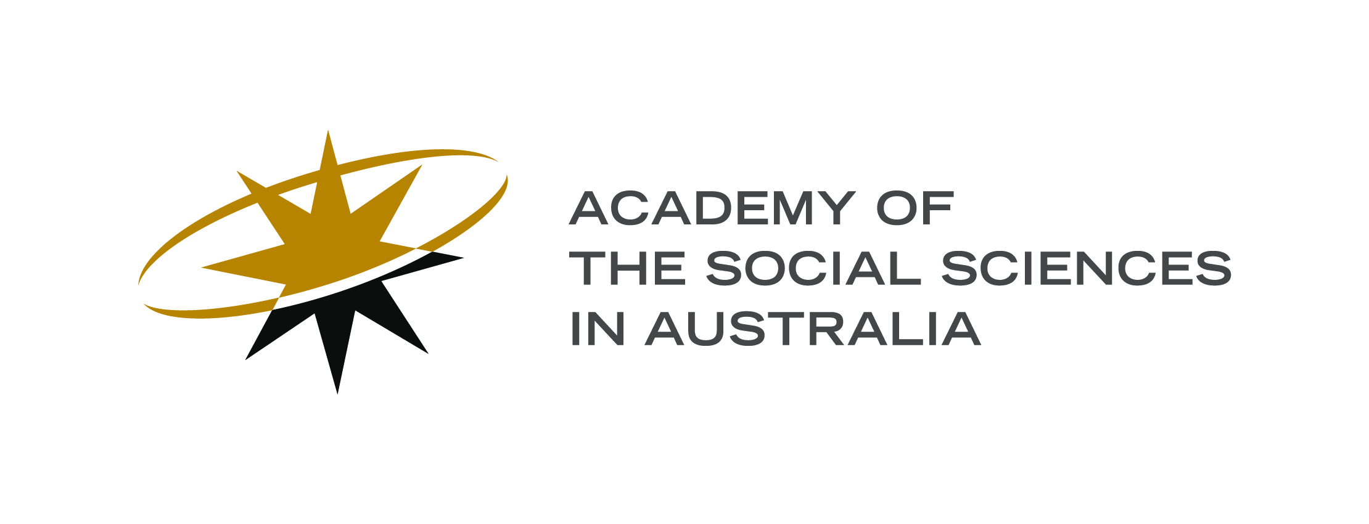
Appendix C: Participant feedback
Before participants left the workshop, they were asked to complete this short feedback form. Responses have been collated to form part of the final report (Report 1).
Are you comfortable with this anonymous response being included in published reports and articles following the workshop? (please circle the appropriate answer)
YES NO
What part of today’s workshop did you find most valuable?

Do you agree that legitimacy needs to be included as a measure of success for environmental flows programs? (please circle the appropriate answer)
YES NO

What is the most important issue for the future agenda to build trust, engagement and establish legitimacy as a core measure of success for environmental flows programs?

Chris Guest, Sharing the water : one hundred years of River Murray politics (Murray-Darling Basin Authority, 2016); Daniel Connell and R Quentin Grafton (eds), Basin Futures: Water Reform in the Murray-Darling Basin (ANU E Press, 2011).
Brisbane Declaration, Environmental Flows are Essential for Freshwater Ecosystem Health and Human Well‐Being (10th International River Symposium and International Environmental Flows Conference, 3–6 September 2007, Brisbane, Australia, 2007).
Erin L O'Donnell and Dustin E Garrick, 'Defining Success: a Multi-Criteria Approach to Guide Evaluation and Investment' in Avril Horne et al (eds), Water for the Environment: From policy and science to implementation and management (Academic Press, 2017) 625.
Fritz W Scharpf, Governing in Europe: Effective and Democratic? (Oxford University Press, 1999).
Karl Hogl et al, 'Legitimacy and Effectiveness of Environmental Governance – Concepts and Perspectives' in Karl Hogl et al (eds), Environmental Governance: The Challenge of Legitimacy and Effectiveness (Edward Elgar, online ed, 2012) 1.
Ibid.
OECD, 'OECD Principles on Water Governance: welcomed by Ministers at the OECD Ministerial Council Meeting on 4 June 2015' (Directorate for Public Governance and Territorial Development, 2015) <http://www.oecd.org/governance/oecd-principles-on-water-governance.htm>.
D E Fisher, 'Water Resource Governance and the Law' (2006) 11(1) The Australasian Journal of Natural Resources Law and Policy 1; Avril Horne et al, 'Moving Forward – the Implementation Challenge for Environmental Water Management' in Avril Horne et al (eds), Water for the Environment: From policy and science to implementation and management (Academic Press, 2017) 649.
R Quentin Grafton et al, 'An Integrated Assessment of Water Markets: A Cross-Country Comparison' (2011) 5(2) Review of Environmental Economics and Policy 219; Barry Hart and Jane Doolan (eds), Decision Making in Water Resources Policy and Management: An Australian Perspective (Academic Press, 2017).
K Matthews, Independent Investigation into NSW Water Management and Compliance: Interim Report (NSW Government, 2017).
Australian Government, 'Our North, Our Future: White Paper on Developing Northern Australia ' (Australian Government, 2015) <http://industry.gov.au/ONA/WhitePaper/Documents/northern_australia_white_paper.pdf>.
Lily O'Neill et al, 'Australia, Wet or Dry, North or South: Addressing Environmental Impacts and the Exclusion of Aboriginal Peoples in Northern Water Development' (2016) 33 Environmental and Planning Law Journal 402.
Brisbane Declaration, above n 2.
John C Conallin et al, 'Stakeholder Engagement in Environmental Water Management' in Avril C Horne et al (eds), Water for the Environment: From Policy and Science to Implementation and Management (Academic Press, 2017) 129.
We acknowledge that ‘efficiency’ is a term with multiple meanings, but in this instance, we refer to productive (not allocative) efficiency: how much outcome was achieved for what cost?
Dustin Evan Garrick, Water Allocation in Rivers Under Pressure: Water Trading, Transaction Costs, and Transboundary Governance in the Western USA and Australia (Edward Elgar, 2015).
The decision about how much water to allocate to environmental or consumptive users is one of allocative efficiency, which can be influenced by productive efficiency; see, for example, Avril Horne et al ‘Environmental water efficiency: maximising benefits and minimising costs of environmental water use and management’ (forthcoming), WIRES Water.
Wentworth Group of Concerned Scientists, 'Review of Water Reform in the Murray-Darling Basin' (Wentworth Group, 2017) <http://wentworthgroup.org/wp-content/uploads/2017/12/Wentworth-Group-Review-of-water-reform-in-MDB-Nov-2017-Review-Report.pdf>; see also discussion in Paul Kildea and George Williams, 'The Water Act and the Murray-Darling Basin Plan' (2011) 22(1) Public Law Review 9.
Natalie Kotsios, Murray Darling Basin Plan: New twist on extra water (24 January 2018) The Weekly Times <https://www.weeklytimesnow.com.au/news/water/murray-darling-basin-plan-new-twist-on-extra-water/news-story/4d77222a157a51231e2d64ce09582520>

