Audio Recording Healthcare Appointments:
Information for Healthcare Professionals about the Law

Patients and healthcare professionals sometimes want to record a consultation. They might not know whether they are allowed to do this under the law.

This fact sheet sets out how the law in Victoria, Australia, applies to healthcare consultation audio recording. The advice is relevant for healthcare professionals.

Why record a healthcare consultation?
Recording consultations can help patients remember important information that was discussed, understand their health problem and treatment, and follow medical advice. They can also use recordings to share important information with others involved in their care. You, as a healthcare professional, might record a consultation for the patient. You might also record as part of a patient’s diagnosis or care, or for other reasons like quality improvement or research.

What is ‘consent’?
‘Consent’ means freely giving permission. Consent can be verbal or written. Consent should be asked for upfront rather than after a recording is made.

Want to record? Things to think about first.
In Victoria, here’s what the law says:

When healthcare professionals record
If you’re making a recording, you must usually get the patient’s consent,, although there are some exceptions under the law.

Sometimes, a patient is asked to give broad consent for information collection when they first attend a health service, and this broad consent might cover consultation recording. It is still a good idea to ask for consent each time you plan to record, to maintain the patient’s trust.

When patients record
Patients can record their face-to-face consultation with you without your consent. However, they usually do need your consent to play or send this recording to others (unless a legal exception applies). Your health service might have its own policies about recording, too. It’s best to have a conversation about recording that covers both the act of making the recording, and what the patients can do with that recording later.

To record telehealth consultations that use a phone or computer, by law everyone on the call must give their consent before a recording is made.

What if I don’t consent, but a patient still records?
You don’t have to continue with a consultation if a patient insists on recording against your wishes.
If your patient asks to record, and you prefer that they don’t, try finding out more. What do they want to record, and why? You may be able to offer other options like writing down information or recording a summary at the end of the visit. Aim to reach a compromise that meets everyone's needs.

Storing and accessing consultation recordings
If you make a recording, store it as you would other types of health information in the patient’s record, rather than on your personal device. For adult patients, keep recordings for 7 years after the person last received care from the health service. For children, keep recordings until they are 25 years old. This is the same for records stored at the health service, or by a health-service approved third party like a cloud storage provider.

Patients don’t have these storage obligations.

In most cases, patients have a right to access recordings that you make. Patients, health services and software companies providing recording apps may also have rights in a recording. You may need specialist legal advice.

Using and disclosing recordings
If you record a consultation to support patient care, you can only play or send it to someone else in limited circumstances. Some examples are:
- With the patient’s consent, it can be sent to a healthcare professional like their GP.
- If the patient cannot consent, for instance due to incapacity, it could be played to an immediate family member for compassionate reasons.
- Without the patient’s consent, in the course of legal proceedings.

If a patient records their consultation, in most instances they can’t play or send it to anyone else without your consent (although there are some exceptions). Legal penalties may apply.

Summary
Recording and listening back to consultations can be beneficial for patients. Know what the laws and local policies are before making or agreeing to a recording. Patients can’t be recorded without their consent. Health professionals can be in some circumstances – but it’s still usually better if a patient asks for consent. Recordings of telehealth consultations always require the consent of everyone on the call.

This information is current as at 7 June 2022. It does not constitute formal legal advice. Health services may have their own policies about recording – this information sheet only covers what the law says. If you need further information, contact your employer, professional organisation or medical indemnity insurer, or seek legal advice. The laws outlined here only apply in Victoria, Australia and are different to those in other states and territories of Australia. This information is relevant to all health care settings in Victoria, Australia. This fact sheet has been developed by researchers at Melbourne Law School and the Peter MacCallum Cancer Centre. For more information visit https://go.unimelb.edu.au/8pje This work is licensed under CC BY-NC-SA 4.0. To view a copy of this license, visit http://creativecommons.org/licenses/by-nc-sa/4.0/

You want to make a recording

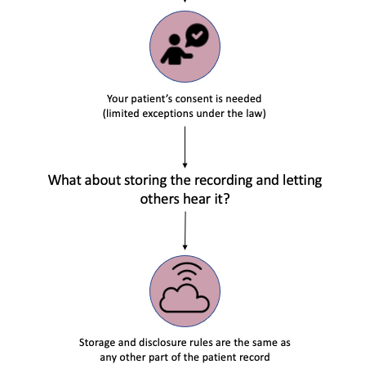

Your patient wants to make a recording

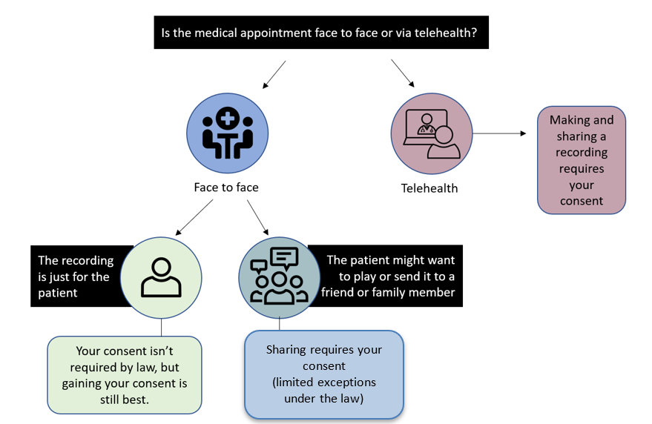

Health Records Act 2001 (Vic) Sch 1 cl 1.1.
Privacy Act 1988 (Cth) Sch 1 cl 3.
Surveillance Devices Act 1999 (Vic).
Surveillance Devices Act 1999 (Vic) s 11.
Telecommunications (Interception and Access) Act 1979 (Cth) ss 6(1), 7(1).
Australian Medical Council, Good medical practice: a code of conduct for doctors in Australia (October 2020) 13.
Health Records Act 2001 (Vic) Sch 1 cl 4.2(b).
Health Records Act 2001 (Vic) Sch 1 cl 4.2(b).
Office of the Australian Information Commissioner, https://www.oaic.gov.au/privacy/health-information/access-your-health-information (accessed 7 June 2022).
Health Records Act 2001 (Vic) Sch 1 cl 6.1 Freedom of Information Act 1982 (Vic) s 13, Privacy Act 1988 (Cth) Sch 1 cl 12.
Privacy Act 1988 (Cth) s 16B(5); Health Records Act 2001 (Vic) Sch 1 cl 2.4.

