Audio Recording Healthcare Appointments:
Information for Patients and their Families about the Law

Patients sometimes want to record their consultation (appointment) with a doctor, nurse or other healthcare professional, so they can listen back to it later. This can help them remember information and follow medical advice. They might not know whether they are allowed to do this under the law.

This fact sheet sets out how the law in Victoria, Australia, applies to healthcare consultation audio recording. This advice is relevant for patients and their families.

Why record a healthcare consultation?
Having a recording of your consultation may help you to:
- remember important information that was discussed
- better understand your health problem and how to treat it
- feel more confident about healthcare decisions
- share important information with other people involved in your care
What is ‘consent’?
‘Consent’ means freely giving permission. Consent can be verbal or written. Consent should be asked for upfront rather than after a recording is made.

Want to record? Things to think about first.
In Victoria, here’s what the law says:
If you are in a face-to-face consultation, you’re not legally required to get the health professional’s permission.
Still, it’s usually better to do this, so that everyone understands that a recording is being made.
This law differs in different parts of Australia. If you’re not sure, asking for permission is usually the best option.
If you are on a telehealth call using a phone or computer, by law everyone on that call must give their permission before a recording is made.
This law is the same wherever you are in Australia.
If you want to play or send your recording to another person later, you usually need the health professional’s permission. It’s easiest to get this permission at the time of the appointment; it must be before you play or send the recording to another person.
This law differs in different parts of Australia. In Victoria, you need consent to play or send a consultation recording to another person unless a legal exception applies.

What if a health professional says no?
Making a recording
When you ask a health professional for their permission to record, they might say no. This could be because they prefer not to be recorded, or their health service might not allow it.

You won’t be breaking the law if you record your face-to-face appointment without their permission, but it may affect your relationship with them, and they could ask you to see another doctor instead. Consider other options, like asking them to record a short summary at the end of your appointment, or to write down notes for you.

Playing or sending a recording to someone else
When you ask a health professional for their permission to play or send a recording to someone else, they might say no. Doing so without their permission is usually against the law unless an exception applies.

Storing consultation recordings
Where recordings are stored depends on who makes the recording.

If your healthcare provider makes the recording, you usually have a legal right to access it.

If you make a recording on your own device, it isn’t part of your official record. It’s your responsibility.
- Keep your recordings in a safe place. Securing your phone with a password, ‘face unlock’ or similar can help protect your recordings.
- Know where your recording is backed up to.
- Check the terms and conditions of the recording app, since the app company might also be able to access the recording.

Sharing recordings
If your health professional gives permission, you can play or send your recording to others. This includes close family, friends, caregivers or other healthcare providers.

Share responsibly
Only let trusted people hear the recordings. This might include relevant health professionals, close family or friends, and carers.
You could keep the recordings on your phone and play them to a someone in a private setting. Or send a recording to a trusted person who is located elsewhere. It is best to send the recording to that person directly and securely. Don’t use social media to share recordings.

Can your health professional play or send a recording to others?
Your health professional might make a recording (with your consent) as part of your care. Then the recording becomes part of your medical record, protected by the law. It could be played or sent:
- to another health professional (like your GP) with your permission, and
- in rare situations, without your permission, with close family members. This could include situations when you could not talk for yourself.

Summary
Recording and listening back to your consultations can be beneficial. Know what the law says about consultation recording before you record.

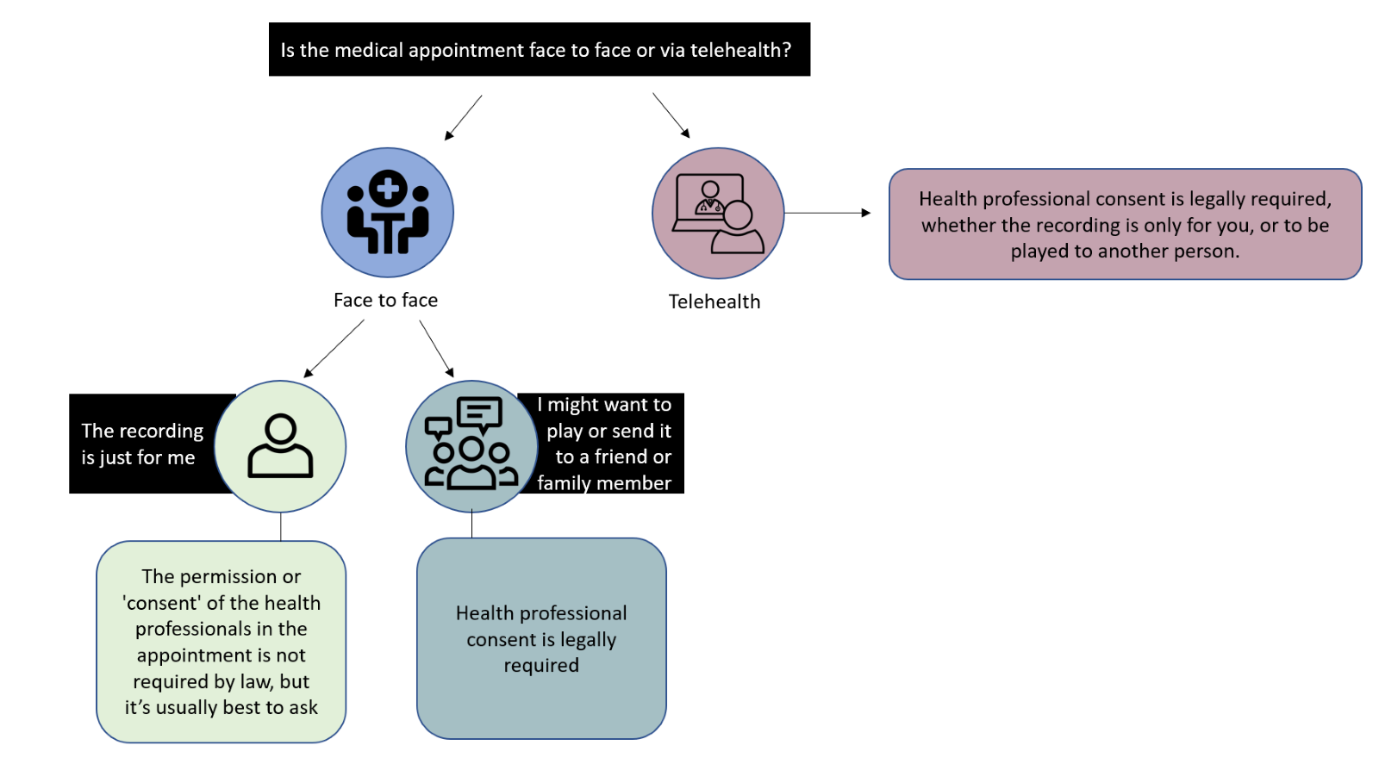

This information is current as of 7 June 2022. It does not constitute formal legal advice. If you have any questions, you can contact the Victorian Health Complaints Commissioner, a legal professional or community legal centre. The laws outlined here only apply in Victoria, Australia and are different to those in other states and territories of Australia. This information is relevant to all health care settings in Victoria, Australia.

This fact sheet has been developed by researchers at Melbourne Law School and the Peter MacCallum Cancer Centre. For more information visit https://go.unimelb.edu.au/8pje. This work is licensed under CC BY-NC-SA 4.0. To view a copy of this license, visit http://creativecommons.org/licenses/by-nc-sa/4.0/

Surveillance Devices Act 1999 (Vic).
Telecommunications (Interception and Access) Act 1979 (Cth) ss 6(1), 7(1).
Surveillance Devices Act 1999 (Vic) s 11.
Australian Medical Council, Good Medical Practice: A Code of Conduct for Doctors in Australia (October 2020) 13.
Surveillance Devices Act 1999 (Vic) s 6(2)(b)(c).
Office of the Australian Information Commissioner, https://www.oaic.gov.au/privacy/health-information/access-your-health-information (accessed 7 June 2022); Health Records Act 2001 (Vic) Sch 1 cl 6.1 Freedom of Information Act 1982 (Vic) s 13, Privacy Act 1988 (Cth) Sch 1 cl 12.
Surveillance Devices Act 1999 (Vic) s 11.
Office of the Australian Information Commissioner, https://www.oaic.gov.au/privacy/health-information/handling-health-information (accessed 7 June 2022); Health Complaints Commissioner (Victoria), https://hcc.vic.gov.au/public/health-records-individuals (accessed 7 June 2022).
Privacy Act 1988 (Cth) s 16B(5); Health Records Act 2001 (Vic) Sch 1 cl 2.4.

